Министерство цифрового развития
Федеральное государственное бюджетное образовательное учреждение
высшего образования
«Сибирский государственный университет телекоммуникаций и информатики»
СибГУТИ

Кафедра прикладной математики и кибернетики

Отчёт
Разработка сетевого приложения. Mini MTA SMTP

Выполнил:
Студент группы ИП-316 Иванов Артём

Проверил:
Преподаватель каф. ПМ и К Истомина А.С.

Новосибирск 2026 г.

Содержание

Постановка задачи 3
Описание вашей реализации 4
Скан экрана работы вашей программы 6
Текст программы 8
Список источников 33

Постановка задачи
Реализация mini MTA SMTP
- Продумать DKIMSigner для унификации ключей отправителей
- SPFValidator по MX записям DNS для корректной работы со внешними почтами.
- Реализовать храниение историй отправленный писем в БД (PostgreSQL)
- Сделать свой поддельный TLC-сертификат
- Использовать поддельный TLC-сертификат для демонстрации работы программы в TLC-сокете и шифровкой
- Разработать очередь для корректной отправки сообщений с нескольких узлов

Описание вашей реализации
- Реализовал обработку писем:
  - Парсинг отправителя и получателя.
  - Проверка SPF (SPFValidator).
  - Определение спама (SpamDetector).
  - Подписание DKIM (DKIMSigner).
  - Добавление письма в очередь (MailQueue.enqueue()).
- Класс SMTPServer:
  - Поднимает сервер на указанном порту (0 → случайный свободный порт).
  - Принимает TCP-подключения.
  - Создаёт отдельный поток SMTPConnection для каждого клиента.
  - Поддерживает остановку и закрытие сервера.
- Соединение SMTP (SMTPConnection)
  - Поддержка команд:
    - EHLO / HELO — приветствие.
    - MAIL FROM — установка отправителя с проверкой SPF.
    - RCPT TO — установка получателя.
    - DATA — приём текста письма.
    - RSET — сброс текущей сессии.
    - QUIT — завершение сессии.
    - STARTTLS — апгрейд соединения на TLS.
- TLS:
4.1 Используется TLSUpgrade.createSSLContext() для генерации SSLContext.
4.2 Поддержка TLSv1.2 и TLSv1.3.
4.3 Возможность запрета повторных handshakes (setEnableSessionCreation(false)).
- Обработка писем:
5.1 Парсинг отправителя и получателя.
5.2 Проверка SPF (SPFValidator).
5.2 Определение спама (SpamDetector).
5.3 Подписание DKIM (DKIMSigner).
5.4 Добавление письма в очередь (MailQueue.enqueue()).
- TLS/SSL (TLSUpgrade)
6.1 Загрузка ключей из keystore.jks.
6.2 Создание SSLContext с KeyManager и TrustManager.
6.3 Используется для апгрейда SMTP-сессий через STARTTLS.

Скан экрана работы вашей программы
Поднятие контейнера для тестовых писем Mail Hog docker run -d -p 1025:1025 -p 8025:8025 mailhog/mailhog открыть http://localhost:8025/#
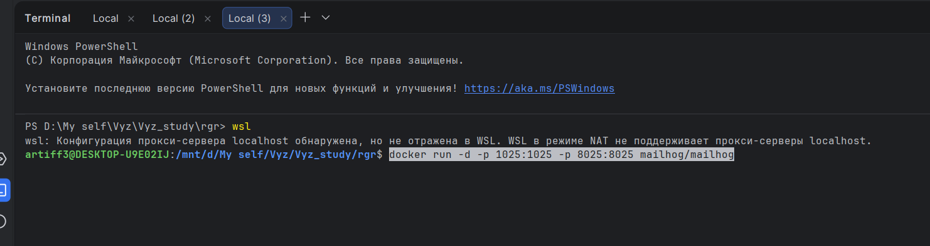
Тестирование через telnet
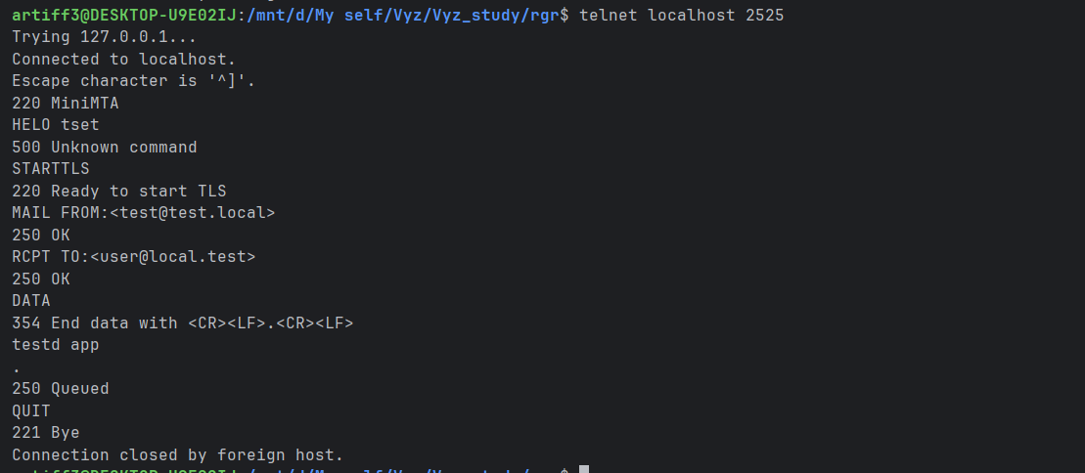
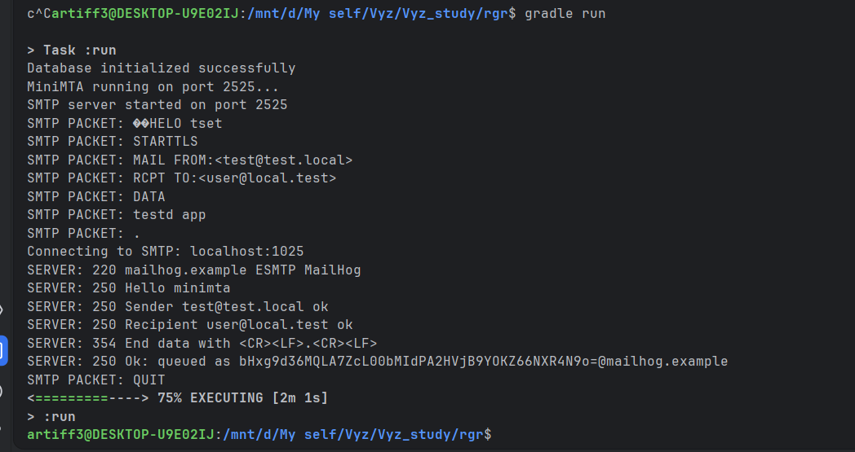
Работа TLC с помощью openssl s_client -connect localhost:35031 -starttls smtp -tls1_2 -crlf -ign_eof
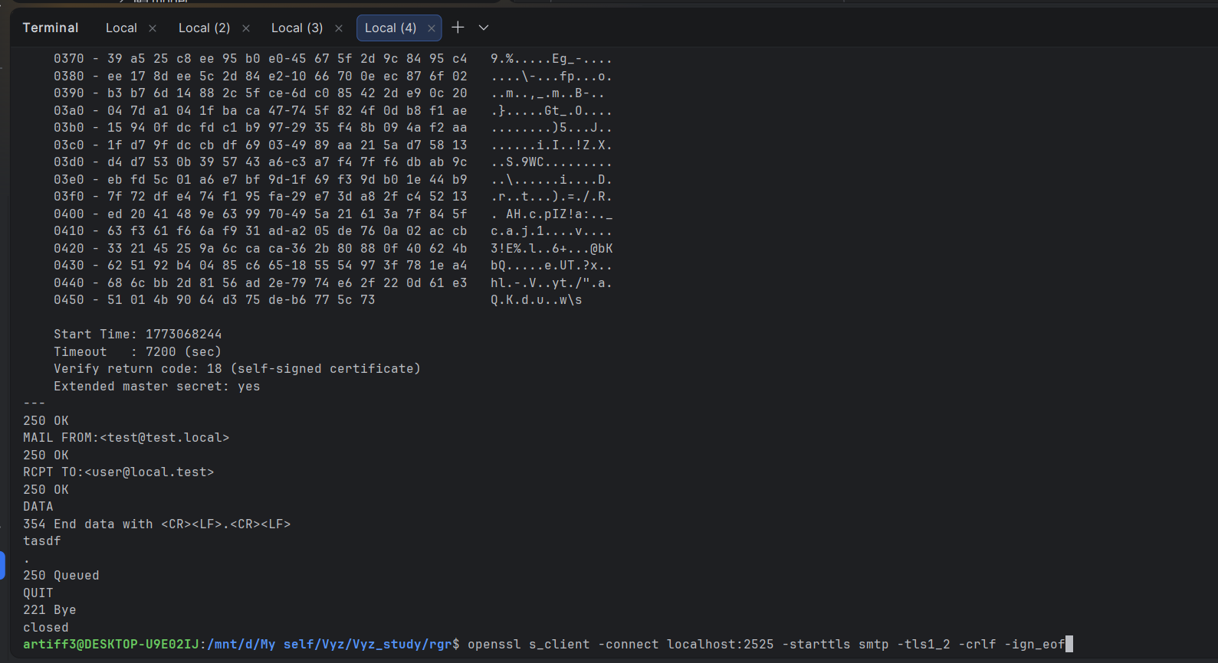
Работа фильтра спама
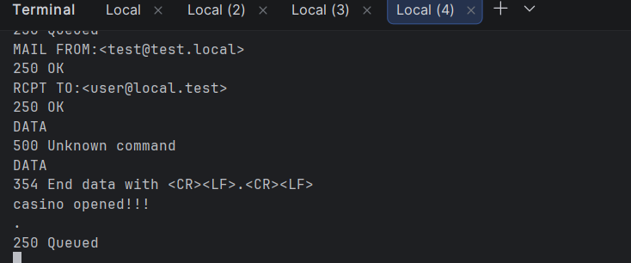

Текст программы
Main.class
package mta;

import mta.db.Database;
import mta.queue.RetryWorker;
import mta.smtp.SMTPServer;

import java.util.concurrent.ExecutorService;
import java.util.concurrent.Executors;
import java.util.concurrent.TimeUnit;

public class Main {

public static void main(String[] args) throws Exception {

Database.init();

ExecutorService executor = Executors.newFixedThreadPool(2);

RetryWorker retryWorker = new RetryWorker();
executor.submit(retryWorker);

SMTPServer server = new SMTPServer(0);
executor.submit(() -> {
try {
server.start();
} catch (Exception e) {
e.printStackTrace();
}
});

System.out.println("MiniMTA running on port 2525...");

Runtime.getRuntime().addShutdownHook(new Thread(() -> {
System.out.println("\nShutting down MiniMTA...");

server.stop();
executor.shutdown();
try {
if (!executor.awaitTermination(5, TimeUnit.SECONDS))
executor.shutdownNow();
} catch (InterruptedException e) {
executor.shutdownNow();
}

System.out.println("MiniMTA stopped");
}));
}
}

SMTPServer.class
package mta.smtp;

import java.io.IOException;
import java.net.ServerSocket;
import java.net.Socket;

public class SMTPServer {

private int port;
private ServerSocket server;
private volatile boolean running = false;

public SMTPServer(int port) {
this.port = port;
}

public void start() throws IOException {
server = new ServerSocket(port);
port = server.getLocalPort();
running = true;

System.out.println("SMTP server started on port " + port);

while (running) {
try {
Socket socket = server.accept();
new Thread(new SMTPConnection(socket)).start();
} catch (IOException e) {
if (running) {
e.printStackTrace();
} else {
break;
}
}
}

close();
}

public void stop() {
running = false;
System.out.println("Stopping SMTP server...");

try {
if (server != null && !server.isClosed()) {
server.close();
}
} catch (IOException e) {
e.printStackTrace();
}
}

private void close() {
try {
if (server != null && !server.isClosed()) {
server.close();
}
System.out.println("SMTP server stopped");
} catch (IOException e) {
e.printStackTrace();
}
}
}
SMTPParser.class
package mta.smtp;

import java.util.regex.Matcher;
import java.util.regex.Pattern;

public class SMTPParser {

private static final Pattern EMAIL_PATTERN =
Pattern.compile("<([^>]+)>");

public static String parseAddress(String line) {

Matcher matcher = EMAIL_PATTERN.matcher(line);

if (matcher.find()) {
return matcher.group(1);
}

return null;
}

public static SMTPCommand parseCommand(String line) {

line = line.toUpperCase();

if (line.startsWith("HELO"))
return SMTPCommand.HELO;

if (line.startsWith("EHLO"))
return SMTPCommand.EHLO;

if (line.startsWith("MAIL FROM"))
return SMTPCommand.MAIL_FROM;

if (line.startsWith("RCPT TO"))
return SMTPCommand.RCPT_TO;

if (line.startsWith("DATA"))
return SMTPCommand.DATA;

if (line.startsWith("QUIT"))
return SMTPCommand.QUIT;

if (line.startsWith("STARTTLS"))
return SMTPCommand.STARTTLS;

return SMTPCommand.UNKNOWN;
}

public static String extractDomain(String email) {

if (email == null)
return null;

int index = email.indexOf("@");

if (index == -1)
return null;

return email.substring(index + 1);
}

public static boolean isValidEmail(String email) {

if (email == null)
return false;

return email.matches(
"^[A-Za-z0-9+_.-]+@[A-Za-z0-9.-]+$"
);
}
}
TLSUpgrade.class
package mta.smtp;

import javax.net.ssl.*;
import java.io.FileInputStream;
import java.security.KeyStore;

public class TLSUpgrade {

private static final String KEYSTORE_PATH = "keystore.jks";
private static final String KEYSTORE_PASSWORD = "changeit";

public static SSLContext createSSLContext() throws Exception {
KeyStore ks = KeyStore.getInstance("JKS");
try (FileInputStream fis = new FileInputStream(KEYSTORE_PATH)) {
ks.load(fis, KEYSTORE_PASSWORD.toCharArray());
}

KeyManagerFactory kmf = KeyManagerFactory.getInstance(KeyManagerFactory.getDefaultAlgorithm());
kmf.init(ks, KEYSTORE_PASSWORD.toCharArray());

TrustManagerFactory tmf = TrustManagerFactory.getInstance(TrustManagerFactory.getDefaultAlgorithm());
tmf.init(ks);

SSLContext sslContext = SSLContext.getInstance("TLSv1.2");
sslContext.init(kmf.getKeyManagers(), tmf.getTrustManagers(), null);

return sslContext;
}
}

SMTPConnection.class
package mta.smtp;

import mta.model.MailMessage;
import mta.queue.MailQueue;
import mta.security.DKIMSigner;
import mta.security.KeyProvider;
import mta.security.SPFValidator;
import mta.spam.SpamDetector;

import javax.net.ssl.*;
import java.io.*;
import java.net.Socket;
import java.nio.charset.StandardCharsets;

public class SMTPConnection implements Runnable {

private Socket socket;
private boolean isTLS = false;

public SMTPConnection(Socket socket) {
this.socket = socket;
}

@Override
public void run() {
try {
BufferedReader in = new BufferedReader(new InputStreamReader(socket.getInputStream(), StandardCharsets.US_ASCII));
BufferedWriter out = new BufferedWriter(new OutputStreamWriter(socket.getOutputStream(), StandardCharsets.US_ASCII));

out.write("220 MiniMTA\r\n");
out.flush();

String sender = null;
String recipient = null;
boolean spfPass = false;
boolean inData = false;
StringBuilder data = new StringBuilder();

String line;
while ((line = in.readLine()) != null) {
line = line.trim();
System.out.println("SMTP PACKET: " + line);

// ===== DATA режим =====
if (inData) {
if (line.equals(".")) {
processData(sender, recipient, spfPass, data.toString());
out.write("250 Queued\r\n");
out.flush();

sender = null;
recipient = null;
spfPass = false;
inData = false;
data = new StringBuilder();
continue;
} else {
data.append(line).append("\r\n");
continue;
}
}

String upper = line.toUpperCase();

// ===== EHLO / HELO =====
if (upper.startsWith("EHLO") || upper.startsWith("HELO")) {
out.write("250-MiniMTA\r\n");
out.write("250-STARTTLS\r\n");
out.write("250 OK\r\n");
}
// ===== MAIL FROM =====
else if (upper.startsWith("MAIL FROM")) {
sender = SMTPParser.parseAddress(line);
if (sender == null) {
out.write("501 Bad address\r\n");
out.flush();
continue;
}

String domain = SMTPParser.extractDomain(sender);
if (domain.endsWith(".local") || domain.equals("localhost")) {
spfPass = true;
out.write("250 OK\r\n");
} else {
spfPass = SPFValidator.checkSPF(domain);
if (!spfPass) {
sender = null;
out.write("550 SPF check failed\r\n");
} else {
out.write("250 OK\r\n");
}
}
}
// ===== RCPT TO =====
else if (upper.startsWith("RCPT TO")) {
if (sender == null) {
out.write("503 Need MAIL FROM first\r\n");
} else {
recipient = SMTPParser.parseAddress(line);
if (recipient == null) {
out.write("501 Bad address\r\n");
} else {
out.write("250 OK\r\n");
}
}
}
// ===== DATA =====
else if (upper.equals("DATA")) {
if (sender == null || recipient == null) {
out.write("503 Bad sequence of commands\r\n");
} else {
inData = true;
out.write("354 End data with <CR><LF>.<CR><LF>\r\n");
}
}
// ===== RSET =====
else if (upper.equals("RSET")) {
sender = null;
recipient = null;
spfPass = false;
data = new StringBuilder();
inData = false;
out.write("250 Reset OK\r\n");
}
// ===== QUIT =====
else if (upper.equals("QUIT")) {
out.write("221 Bye\r\n");
out.flush();
socket.close();
return;
}
// ===== STARTTLS =====
else if (upper.startsWith("STARTTLS")) {
if (isTLS) {
out.write("454 TLS already active\r\n");
out.flush();
continue;
}

out.write("220 Ready to start TLS\r\n");
out.flush();

try {
SSLContext sslContext = TLSUpgrade.createSSLContext();
SSLSocketFactory factory = sslContext.getSocketFactory();

SSLSocket sslSocket = (SSLSocket) factory.createSocket(
socket,
socket.getInetAddress().getHostAddress(),
socket.getPort(),
true
);

sslSocket.setUseClientMode(false);
sslSocket.setEnabledProtocols(new String[]{"TLSv1.2", "TLSv1.3"});
sslSocket.setEnableSessionCreation(true);
sslSocket.startHandshake();

in = new BufferedReader(new InputStreamReader(sslSocket.getInputStream(), StandardCharsets.US_ASCII));
out = new BufferedWriter(new OutputStreamWriter(sslSocket.getOutputStream(), StandardCharsets.US_ASCII));
this.socket = sslSocket;
isTLS = true;

System.out.println("TLS established: " +
sslSocket.getSession().getProtocol() + " / " +
sslSocket.getSession().getCipherSuite());

} catch (Exception e) {
e.printStackTrace();
out.write("454 TLS not available\r\n");
out.flush();
}
}
// ===== Неизвестная команда =====
else {
out.write("500 Unknown command\r\n");
}

out.flush();
}

} catch (Exception e) {
e.printStackTrace();
}
}

private void processData(String sender, String recipient, boolean spfPass, String messageBody) {
try {
boolean isSpam = SpamDetector.isSpam(messageBody);

String dkimHeader = "";
try {
DKIMSigner signer = new DKIMSigner(KeyProvider.getPrivateKey());
String signature = signer.sign(messageBody);
dkimHeader = "DKIM-Signature: " + signature + "\r\n";
} catch (Exception e) {
e.printStackTrace();
}

String fullMessage =
"From: <" + sender + ">\r\n" +
"To: <" + recipient + ">\r\n" +
"Subject: MiniMTA test\r\n" +
dkimHeader +
"\r\n" +
messageBody + "\r\n";

MailMessage msg = new MailMessage(sender, recipient, fullMessage);
msg.setSpfPass(spfPass);
msg.setSpam(isSpam);

MailQueue.enqueue(msg);
} catch (Exception e) {
e.printStackTrace();
}
}
}

DKIMSigner.class
package mta.security;

import java.security.*;
import java.util.Base64;

public class DKIMSigner {

private PrivateKey privateKey;

public DKIMSigner(PrivateKey key) {
this.privateKey = key;
}

public String sign(String data) throws Exception {

Signature signature =
Signature.getInstance("SHA256withRSA");

signature.initSign(privateKey);

signature.update(data.getBytes());

byte[] signed = signature.sign();

return Base64.getEncoder().encodeToString(signed);
}
}

SPFValidator.class
package mta.security;

import org.xbill.DNS.*;

import java.lang.Record;

public class SPFValidator {

public static boolean checkSPF(String domain) {

try {

Lookup lookup = new Lookup(domain, Type.TXT);

org.xbill.DNS.Record[] records = lookup.run();

if (records == null)
return false;

for (org.xbill.DNS.Record record : records) {

TXTRecord txt = (TXTRecord) record;

for (String value : txt.getStrings()) {

if (value.startsWith("v=spf1")) {
return true;
}
}
}

} catch (Exception e) {
e.printStackTrace();
}

return false;
}
}

RetryWorker.class
package mta.queue;

import mta.db.Database;
import mta.delivery.SMTPClient;
import mta.model.MailMessage;
import mta.dns.MXResolver;

import java.sql.Connection;
import java.sql.PreparedStatement;

public class RetryWorker implements Runnable {

private static final int MAX_RETRIES = 5;
private static final long RETRY_DELAY_MS = 10_000;
private static final long EMPTY_QUEUE_DELAY_MS = 100;

@Override
public void run() {
while (true) {
try {
MailMessage msg = MailQueue.take();

if (msg == null) {
Thread.sleep(EMPTY_QUEUE_DELAY_MS);
continue;
}

String recipient = msg.getRecipient();
if (recipient == null || !recipient.contains("@")) {
System.err.println("Invalid recipient: " + recipient);
continue;
}
String domain = recipient.substring(recipient.indexOf("@") + 1);

String mxHost = MXResolver.resolveMX(domain);
if (mxHost == null || mxHost.isEmpty()) {
System.err.println("Cannot resolve MX for domain: " + domain);
continue;
}

boolean success = SMTPClient.send(msg, mxHost);

if (success) {
try (Connection conn = Database.getConnection()) {
PreparedStatement ps = conn.prepareStatement(
"UPDATE messages SET sent = TRUE WHERE id = ?"
);
ps.setInt(1, msg.getId());
ps.executeUpdate();
} catch (Exception e) {
e.printStackTrace();
}
} else if (msg.getRetryCount() < 5) {
msg.incRetry();
Thread.sleep(10000);
MailQueue.enqueue(msg);
}

} catch (Exception e) {
e.printStackTrace();
}
}
}
}

MailQueue.class
package mta.queue;

import mta.db.Database;
import mta.model.MailMessage;

import java.sql.Connection;
import java.sql.PreparedStatement;
import java.sql.ResultSet;

public class MailQueue {

private static final java.util.Queue<MailMessage> queue = new java.util.LinkedList<>();

public static synchronized void enqueue(MailMessage msg) {
queue.add(msg);

try (Connection conn = Database.getConnection()) {

PreparedStatement ps = conn.prepareStatement(
"INSERT INTO messages (sender, recipient, body, spam, spf_pass) VALUES (?, ?, ?, ?, ?) RETURNING id"
);

ps.setString(1, msg.getSender());
ps.setString(2, msg.getRecipient());
ps.setString(3, msg.getBody());
ps.setBoolean(4, msg.isSpam());
ps.setBoolean(5, msg.isSpfPass());

ResultSet rs = ps.executeQuery();

if (rs.next()) {
msg.setId(rs.getInt(1));
}

} catch (Exception e) {
e.printStackTrace();
}
}

public static synchronized MailMessage take() {
return queue.poll();
}

}

SMTPClient.class
package mta.delivery;

import mta.model.MailMessage;

import java.io.*;
import java.net.Socket;

public class SMTPClient {

private static final boolean TEST_MODE = true;

public static boolean send(MailMessage msg, String mxHost) {

String host;
int port;

if (TEST_MODE) {
host = "localhost";
port = 1025;
} else {
host = mxHost;
port = 25;
}

try (
Socket socket = new Socket(host, port);
BufferedReader in = new BufferedReader(new InputStreamReader(socket.getInputStream()));
BufferedWriter out = new BufferedWriter(new OutputStreamWriter(socket.getOutputStream()))
) {

System.out.println("Connecting to SMTP: " + host + ":" + port);

System.out.println("SERVER: " + in.readLine());

out.write("HELO minimta\r\n");
out.flush();
System.out.println("SERVER: " + in.readLine());

out.write("MAIL FROM:<" + msg.getSender() + ">\r\n");
out.flush();
System.out.println("SERVER: " + in.readLine());

out.write("RCPT TO:<" + msg.getRecipient() + ">\r\n");
out.flush();
System.out.println("SERVER: " + in.readLine());

out.write("DATA\r\n");
out.flush();
System.out.println("SERVER: " + in.readLine());

out.write(msg.getBody() + "\r\n.\r\n");
out.flush();
System.out.println("SERVER: " + in.readLine());

out.write("QUIT\r\n");
out.flush();

return true;

} catch (Exception e) {
e.printStackTrace();
return false;
}
}
}

Database.class
package mta.db;

import java.sql.Connection;
import java.sql.DriverManager;
import java.sql.Statement;

public class Database {

private static final String URL = "jdbc:postgresql://192.168.128.1:5432/mta";

private static final String USER = "postgres";
private static final String PASS = "12345";

public static Connection getConnection() throws Exception {
return DriverManager.getConnection(URL, USER, PASS);
}

public static void init() throws Exception {
try (Connection conn = getConnection();
Statement stmt = conn.createStatement()) {

stmt.executeUpdate(
"CREATE TABLE IF NOT EXISTS messages (" +
"id SERIAL PRIMARY KEY," +
"sender VARCHAR(255) NOT NULL," +
"recipient VARCHAR(255) NOT NULL," +
"body TEXT," +
"queued_at TIMESTAMP DEFAULT CURRENT_TIMESTAMP," +
"sent BOOLEAN DEFAULT FALSE," +
"spam BOOLEAN DEFAULT FALSE," +
"spf_pass BOOLEAN DEFAULT FALSE" +
");"
);

stmt.executeUpdate(
"CREATE TABLE IF NOT EXISTS mail_queue (" +
"id SERIAL PRIMARY KEY," +
"message_id INT REFERENCES messages(id)," +
"retry_count INT DEFAULT 0," +
"next_try TIMESTAMP DEFAULT CURRENT_TIMESTAMP" +
");"
);

System.out.println("Database initialized successfully");
}
}
}

MXResolver.class
package mta.dns;

import org.xbill.DNS.*;

public class MXResolver {

public static String resolveMX(String domain) throws Exception {

Lookup lookup = new Lookup(domain, Type.MX);
org.xbill.DNS.Record[] records = lookup.run();

if (records == null) {
return domain;
}

MXRecord mx = (MXRecord) records[0];

return mx.getTarget().toString();
}
}

MailMessage.class
package mta.model;

public class MailMessage {

private int id;
private String sender;
private String recipient;
private String body;
private int retryCount;
private boolean spam;
private boolean isSpfPass;

public MailMessage(String sender, String recipient, String body) {
this.sender = sender;
this.recipient = recipient;
this.body = body;
this.retryCount = 0;
this.spam = false;
}

public void setSpfPass(boolean spf){
isSpfPass = spf;
}

public boolean isSpfPass() {
return isSpfPass;
}

public boolean isSpam() {
return spam;
}

public void setSpam(boolean spam) {
this.spam = spam;
}

public int getId() {
return id;
}

public void setId(int id) {
this.id = id;
}

public String getSender() {
return sender;
}

public String getRecipient() {
return recipient;
}

public String getBody() {
return body;
}

public void setBody(String body) {
this.body = body;
}

public int getRetryCount() {
return retryCount;
}

public void incRetry() {
retryCount++;
}
}

Список источников
- Java Platform, Standard Edition Documentation
- Stevens, W. Richard. TCP/IP Illustrated, Volume 1: The Protocols. Addison‑Wesley, 1994. — Глава 14: SMTP, стр. ~360–390.
- Harold, Elliotte Rusty. Java Network Programming. O’Reilly Media. — Раздел SSL/TLS с примерами SSLSocket и SSLContext.
- SMTP базовые команды — RFC 5321 Section 4
- DKIM — RFC 6376 Section 3–5
- Lazear, M. & RFC 7208: SPF. IETF, 2014.

